SerpApi
Google Search API Key Generation — Setup Guide

Purpose | Step-by-step guide to generate a SerpApi API key
Website | https://serpapi.com
Free Plan Quota | 250 searches/month (non-commercial use only)

Introduction
SerpApi is a real-time API that allows you to scrape Google and other search engines programmatically. It provides structured JSON results for search queries, making it ideal for building AI agents, SEO tools, market research applications, and more.
This document walks you through the complete process of creating a SerpApi account, verifying your identity, and obtaining your private API key.

Prerequisites
- A web browser (Chrome, Firefox, Edge, etc.)
- A Google or GitHub account (for quick sign-up), or a valid email address
- A phone number for verification (required for free plan activation)

Step 1 | Navigate to SerpApi and Register

1.1 Open your web browser and navigate to serpapi.com.
1.2 The homepage showcases the Google Search API with a live test search demo where you can preview the API’s functionality.
1.3 Click the "Register" button located in the top-right corner of the navigation bar to begin creating your account.

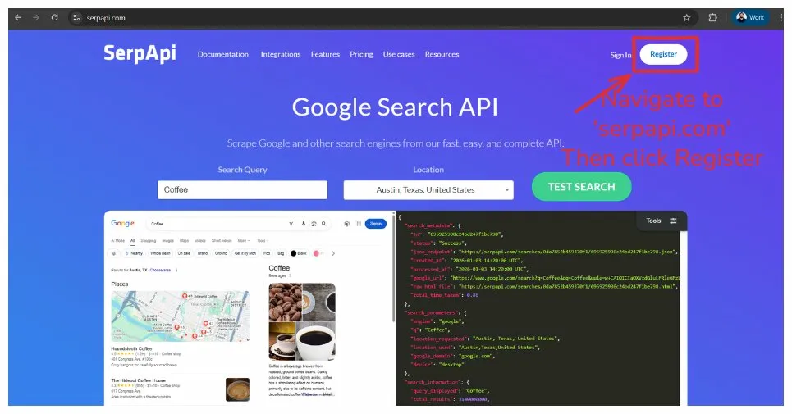

Step 2 | Sign Up for an Account

2.1 On the Sign Up page, you will see multiple registration options.
2.2 Click "Sign up with Google" (recommended) or "Sign up with GitHub" for quick registration.
2.3 Alternatively, fill in the manual registration form with your Full Name, Email, and Password, then click "Sign Up".
2.4 If you already have an account, click the "Sign In" link at the bottom right of the page.

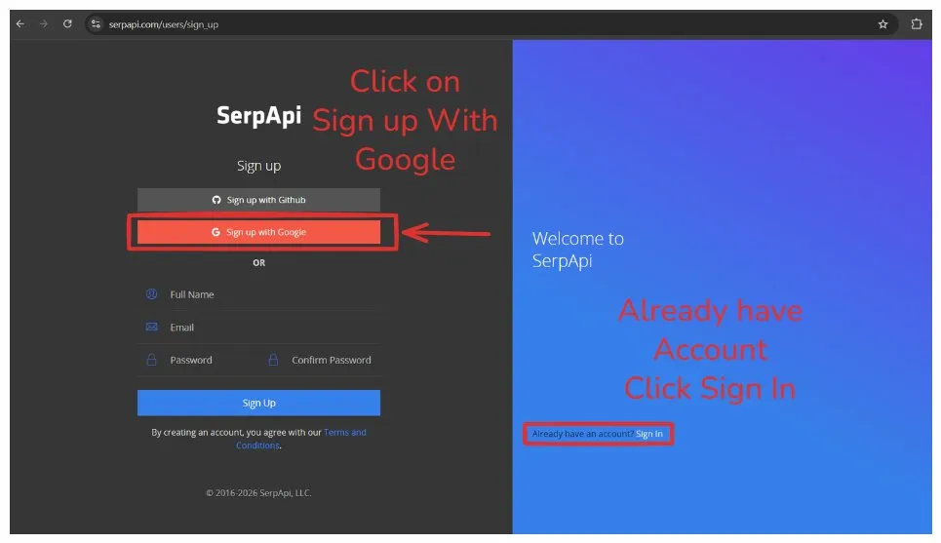

Step 3 | Authorize Google Sign-In

3.1 If using Google sign-in, a popup window will appear titled "Choose an account to continue to serpapi.com".
3.2 Select your preferred Google account from the list. You can also click "Use another account" to sign in with a different account.
3.3 Review the permissions that serpapi.com is requesting, then click the "Continue" button to authorize SerpApi and complete sign-in.

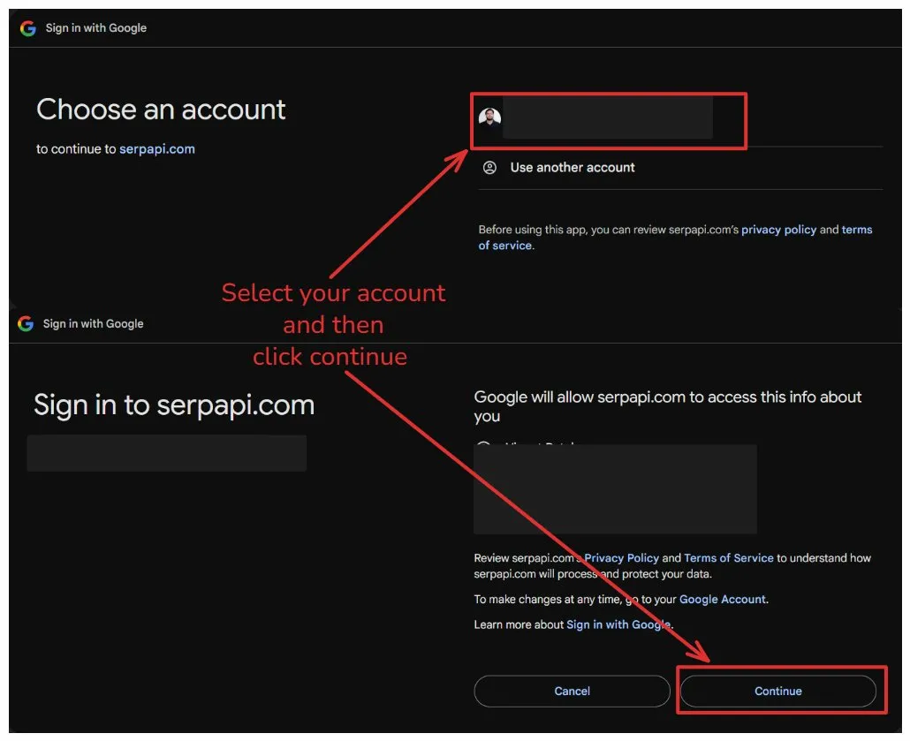

Step 4 | Choose a Plan and Verify Email

4.1 After successful sign-in, you will be redirected to the "Choose a Plan" page. A confirmation message "Successfully signed in with Google" will appear at the top.
4.2 The Free Plan is selected by default, which includes 250 searches/month (non-commercial use only).
4.3 To activate the free plan, you must first verify your email. Check your inbox and click the verification link sent to your email address. If you don’t see the email, click "Resend email".
4.4 You will also need to verify your phone number — click "Verify phone number" to proceed to the phone verification step (covered in Step 5).

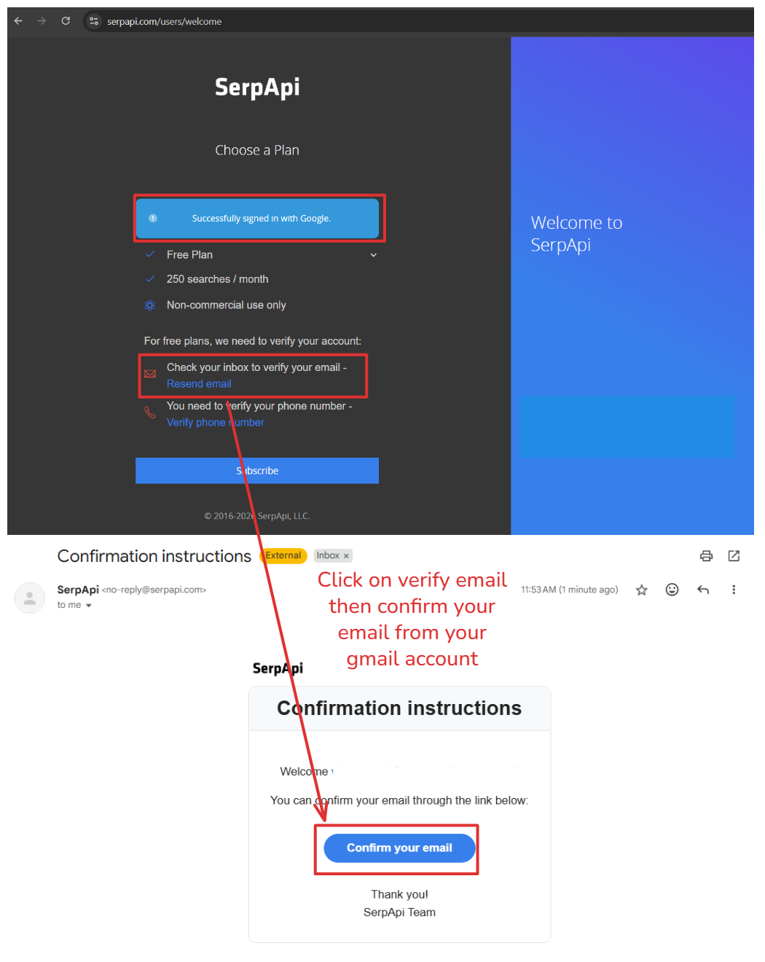

Step 5 | Verify Your Phone Number

5.1 Once your email is verified, a green confirmation message "Your email address has been successfully confirmed" will appear on the plan page.
5.2 Click "Verify phone number" to proceed to the phone verification page.
5.3 Enter your phone number in the "Verification code" field and click "Send Code". A 6-digit verification code will be sent to your phone.
5.4 Enter the 6-digit code in the verification field and click the "Verify" button to complete phone verification.
5.5 Once both email and phone are verified, click the "Subscribe" button on the plan page to activate your free plan.

Note: If you don’t receive the verification code, click "Send new code" to request another one.

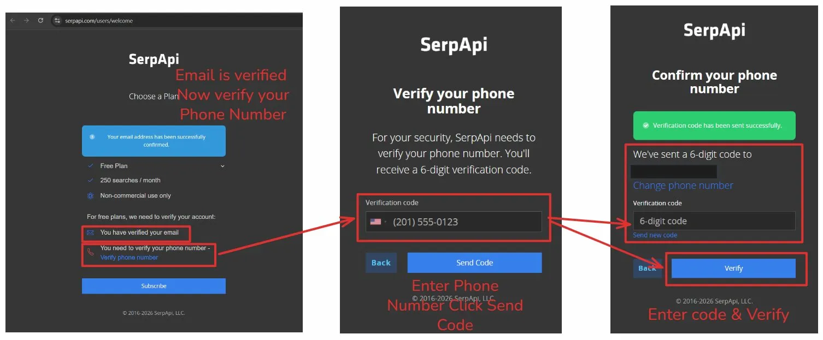

Step 6 | Access Your API Key from the Dashboard

6.1 After verification is complete, you will be redirected to the SerpApi Dashboard at serpapi.com/dashboard. A green banner will confirm: "Welcome to SerpApi! You can now use our API."
6.2 Your account will show 0 / 250 searches available on the Free Plan in the top-right corner.
6.3 In the left sidebar, click "API Key" under the "Your Account" section.
6.4 Your Private API Key will be displayed on the page. Click the copy icon on the right side to copy the key to your clipboard.
6.5 If you ever need to generate a new key, click the "Regenerate API Key" button below the key. Note that this will invalidate your previous key.

Important: Store your API key securely and never share it publicly. If you regenerate a new key, the old key will be immediately invalidated.

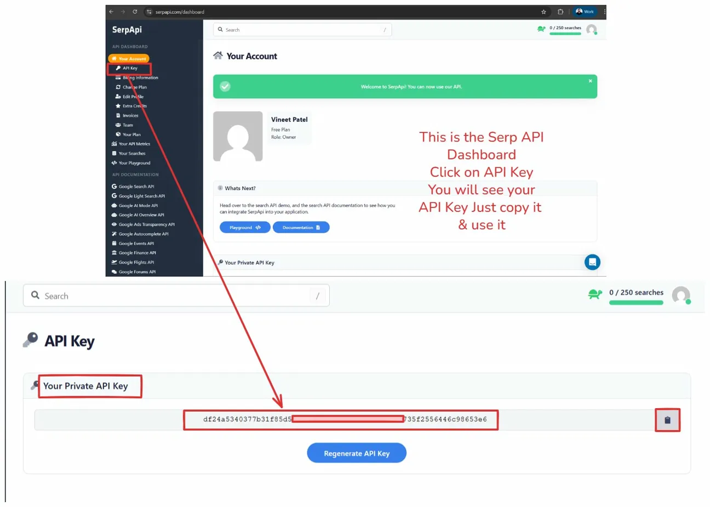

Summary
Step | Action
Step 1 | Navigate to serpapi.com and click "Register"
Step 2 | Sign up using Google, GitHub, or manual email registration
Step 3 | Authorize Google sign-in by selecting your account
Step 4 | Choose the Free Plan and verify your email address
Step 5 | Verify your phone number with a 6-digit code
Step 6 | Access and copy your Private API Key from the Dashboard

You are now ready to integrate SerpApi into your applications!
For API documentation, visit: https://serpapi.com/search-engine-apis

OpenAI API Key – Allowed Models & Troubleshooting
Allowed Models
Your Interview Kickstart OpenAI API key provides access to the following models. Please use only these models for the course projects:
- gpt-4o-mini
- gpt-4o
- tts-1
- whisper-1
- omni-moderation-latest
- text-embedding-3-small
- text-embedding-3-large
- text-embedding-ada-002
Please test your project before the class
We recommend running the project once before the live class by following the provided instructions. This will help you identify and resolve any setup or configuration issues in advance.
If you face a rate limit or quota error during the class:
When multiple learners run the same models simultaneously, some models may temporarily experience high usage. You may see errors such as “Rate limit exceeded” or “Quota exceeded.”
If you encounter these errors:
- Wait for 5–10 minutes and try running the project again.
- Your API key has sufficient credits for the course projects, so please do not worry about the error immediately.
- If the issue continues, try running the project again after the class.
If your API key appears to be invalid or is not working:
You can verify your API key using the OpenAI API Key Tester:
OpenAI API Key Tester: https://trevorfox.com/api-key-tester/openai/
If the key is still not working after verification, please contact the Operations team for support.

